Use Jenkins the DevOps way. Automate your Jenkins jobs by using Jenkins Pipelines, Docker, and the Jenkins Job DSL

Install Docker
1. $ sudo apt-get update
2. $ sudo apt-get install
3. apt-transport-https
4. ca-certificates
5. curl
6. gnupg
7. lsb-release
8. $ curl -fsSL https://download.docker.com/linux/ubuntu/gpg | sudo gpg --dearmor -o /usr/share/keyrings/docker-archive-keyring.gpg
9. $ echo \ "deb [arch=amd64 signed-by=/usr/share/keyrings/docker-archive-keyring.gpg] https://download.docker.com/linux/ubuntu \
10. $(lsb_release -cs) stable" | sudo tee /etc/apt/sources.list.d/
11. docker.list > /dev/null
12. $ sudo apt-get update
13. $ sudo apt-get install docker-ce docker-ce-cli containerd.io
[ See also https://docs.docker.com/engine/install/ubuntu/]

Install Jenkins

1. $ sudo mkdir -p /var/jenkins_home/.
2. $ sudo chown -R 1000:1000 /var/jenkins_home/
3. $ docker run -p 8080:8080 -p 50000:50000 -v /var/.
4. jenkins_home:/var/jenkins_home --name jenkins -d jenkins/jenkins:lts.
5. Open browser and go to: http://IP:8080/ (change IP to your droplet IP).
6. You will be asked for initial password for the Jenkins, you can get this password by entering following command on your server.
7. $ cat /var/jenkins_home/secrets/initialAdminPassword.

Alternative Installation methods

1. Using a Vagrant box: https://github.com/wardviaene/devops-box
2. Works on Mac / Linux / Windows.
3. Download virtualbox at www.virtualbox.org.
4. Download vagrant at www.vagrantup.com.
5. Download the repository, open a cmd/shell/terminal.
6. cd into the project directory.
7. Type “vagrant up”.
8. Without tools, just a plain install on your Linux / Mac / Windows machine:

* What is Jenkins ?
. Jenkins is an open source continuous integration (CI) and continuous delivery (CD) tool written in Java.
. It’s an automation server used to build and deliver software projects
. Jenkins was forked from another project called Hudson, after a dispute with Oracle.
. A major benefit of using jenkins is that it has a lot of plugins available.
. There is easier to use CI software available, but Jenkins is open source, free and still very popular.

* What is CI / CD ?
. Continuous integration (CI) is the practice, in software engineering, of merging all developer working copies to a shared mainline several times a day.
. Continuous delivery (CD) is a software engineering approach in which teams produce software in short cycles, ensuring that the software can be reliably released at any time.
. In Practice: verify and publish work by triggering automated builds & tests.
. For every commit or at least once a day.
. All developers should push their changes to a version control, which should then be built and tested – which can be done by Jenkins.
. Jenkins doesn’t merge code nor it resolves code conflicts, that’s still for the developer to do ( using for instance git and merge tools).

* Benifts
. Jenkins provides a feedback loop back to the developer to fix build errors.
. Research has shown that it’s a lot quicker to have a developer fix the error immediately (when the code is still fresh in memory)
. Jenkins can publish every build of your software.
. This build already has gone through automated testing.
. When published and deployed to a dev/qa/staging server, you can advance the Software development lifecycle (SDLC) much quicker.
. The quicker you can go through an iteration of the SDLC the better .

* CI/CD within the SDLC ( Software development life – cycle)
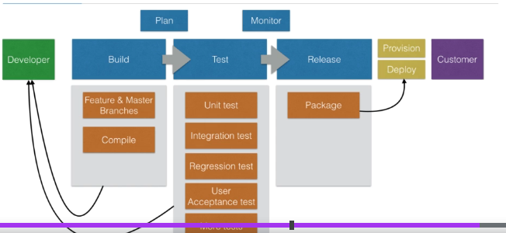
* Jenkins Alternatives
1. Self-hosted
* Drone CI ( Continuous delivery platform written in Go)
* TeamCity ( by Jetbrains)
2. Hosted ( as a service)
* Wercker.
* CircleCI
* CodeShip.
* SemaphoreCI
* Amazon AWS CI/CD tools.

* Jenkins Installation
* Installation methods. --> Installing Jenkins on the Cloud using docker.
1. On the Cloud using docker (works on AWS, DigitalOcean, Google Cloud, Azure.)
2. www.virtuabox.org can run ubuntu in a VM locally.
3. www.vagrantup.com together with virtuabox can spin up a running ubuntu instance in minutes ( see my other DevOps course for an introduction to Vargrant)

* Demo: Jenkins Installation.
1. Digital Ocean – Platforms you can use to setup a VM:
www.digitalocean.com (which I use in this course)
( AWS, Azure, Google Cloud )
Any other Cloud provider / VM that has Ubuntu ( 20.04.x installed).

* Introduction to docker:
1. What is docker?
*. Docker is the most popular container software.
*. Docker Engine
1. The docker runtime.
2. Software to make run docker images
*. Docker Hub
1. Online service to store and fetch docker images.
2. Also allows you to build docker images online.
3. Isolation: you ship a binary with all the dependencies
4. No more “it works on my machine, but not in production”.
5. Closer parity between dev, QA, and production environments.
6. Docker makes development teams able to ship faster.
7. You can run the same docker image, unchanged, on leptops, data center Vms, and Cloud providers.
8. Docker use linux Containers (a kernal feature) for operating system-level isolation.

Virtual Machines vs Containers :-
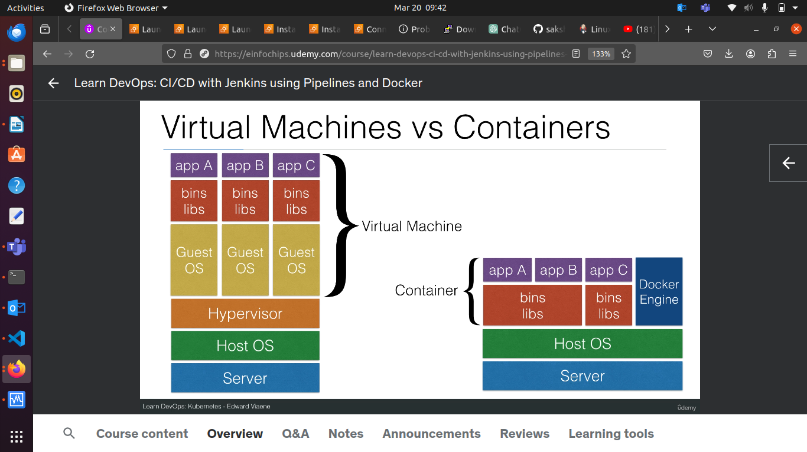

* Why use docker to start Jenkins?

1. Everyone will have the same container image of Jenkins.

2. Regardlesss of your Operating System.

3. You can run docker on an ubuntu on Digital Ocean, but also on a MAC, on Window, etc.

4. You can easily upgrade jenkins by pulling the latest container image.

5. You can modify the jenkins container image by creating your own Dockerfile.

6. Or modify the Dockerfile I have for jenkins in my github repository.

* What is Node.js

1. Node.js is a javascript runtime environment which is:

* Open Source.
* Cross-Platform.

2. Used to execute javascript code server side instead of client side

3. Has a event-driven architecture capable of asynchronous I/O.

4. This makes NodeJS capable of responding very fast to request.

5. e.g. it can immediately give a client the result and asynchronously handle database updates which generally take a longer time.

6. This one of the reasons why Node.js is used so much .

* Node.js users

1. Node.js is used by:

2. Paypal (using Node.js for its customer-facing side of their web applications).

3. Linkedin (to deal with scale)

4. Uber (to process lots of data quickly, address errors on the fly- without restart, and active community that makes NodeJS better over time).

5. Yahoo, Mozilla, Netflix, New York Times, Medium.

* Why Node.js

1. We use a Node.js example project because it’s relatively easy to understand, even when you never have used it before.

2. It doesn’t need to be compiled, so building the app doesn’t take a lot of memory (unlike building java projects)

3. Which is handy if you just want to do this course on small instances.

4. Once you understand how to build a simple node.js project, you can use the knowledge to start building larger, more complex projects.

* How to build a Node.js app

1. Step 1: install dependencies (npm intsall).
* Downloads and installs all the dependencies.

2. Step 2: run test (npm test).
* Runs all the NodeJS tests.
* Typically if a test fails, the build fails and the developer(s) should be notified.
* I’ll explain about slack/bitbucket integrations later on this course.
* After step 1 and step 2 you have an application that is ready to be started.
* The only things you’ll be missing is a package: how do you package and distribute this project so it can be deployed on a server instance?.

3. Step 3: package the app in docker.
* You can create a container that include the Node.js binaries and your project.
* Rather than creating a .zip, .jar, or .tgz package, you package a binary that includes all binaries and dependencies.
* That way you’re sure that the code will behave the same on the production system as your dev/test/staging/qa machines.
* It gives you closer dev-prod parity.

4. Step 4: distribute the docker image.
* You can use a docker registry to upload your docker images.
* Those images can be set public ( everyone can access them ) or private.
* Example: Docker Hub, Amazon AWS’s Container Registry.

* Infrastructure as code and automation.
* Jenkins allows you to use a web UI to input all the build parameters.
* This leads to:
* No proper audit trail.istory
* No easy history of changes.
* Segregation between Jenkins admins and developers.
* Users (often developers) will have to contact a Jenkins administartor to make changes.
* Long lead times for changes.
* Difficult to backup and restore ( e.g. how to restore just one setting to how it wast the day before).
* The solution is to completely write jobs as code and save it in version control.
* Version Control (git/ subversion/ mercurial) gives you a history and audit trail.
* Easy roll back to older versions of jobs and build instructions.
* Allows operations to give more control to the developers.
* Developers can bundle the jenkins build instructions with their own project repository (e.g. a Jenkinsfile in their project directory)
* This is what a comapny that wants to embrace DevOps should do: allow developers to control their own builds
* In the next sections, I’ll cover 2 Jenkins capabalities to enable Jenkins to be a true DevOps tool within your software organization:
* Jenkins Job DSL
* Write code that creates and modifies jenkins jobs automatically.
* Jenkins Pipeline ( Jenkinsfile).
* Bundle the build parameters within the project
* Allow developers to change jenkins build parameters.
* Enable audit trail, history, rollbacks using version control.

* Jenkins Job DSL
* The Jenkins Job DSL plugin was designed to make it easier to manage jobs.
* If you don’t have a lot of jobs, using the UI is the easiest way.
* When the jobs grow, maintaining becomes difficult and a lot of work .
* The Jenkins Plugin solves this problem, and you get a lot of extra benefits.
* Version control, history, audit log, easier job restore when something goes wrong.
* An example (npm install)\
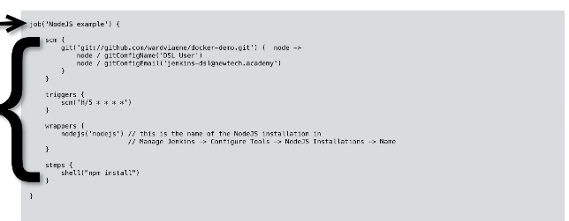
* Jenkins Pipelines.
* Jenkins Pipeline allow you to write the Jenkins build steps in code.
1). Build steps aalow you to write build (compile), test, deploy in code.
2). Code means you can put this code in version control.
It’s about automating this cycle:

* Jenkins Pipelines vs Job DSL

* How are Jenkins Pipeline different than the Jenkins Job DSL?

1. They both have the capability to write all your CI/CD in code.
2. The difference is in implementation in Jenkins.
3. Jenkins Job DSLs creates new jobs based on the code you write.
4. The Jenkins Pipeline is a job type, you can create a Jenkins pipeline job that will handle the build/test/deployment of one project.
5. Can I now start using pipelines and forget everything about Jenkins Job DSL?
6. You could use Jenkins Job DSLs to create new pipeline jobs.
7. Until now we’ve only created freestyle projects with the Jenkins Job DSL
8. Another possibility would be to use an “Organization folder” , which is a feature of Jenkins Pipelines to detect the project repositories, removing the need to add new jobs.
9. It’ll really depend on your needs for what option you’ll need to go.

* Jenkins Pipelines Example.

